Objections to CBAS5 Bridleway/Brown Track Diversion Order
Ref: AR/PC 71/2017/10
Dear Ms Roberts,
I am writing to object to the temporary diversion order for the footpath and Bridleway No 5 (CBAS5) for a period of 6 years due to the construction of a quarry field conveyor by Hills Waste Solutions Limited/Hills Quarry Products Limited on the basis that:
1. The Bridleway/Brown Track is protected by condition g of the original dormant ROMP permission

2. The proposed Bridleway diversion route is unsuitable both as a Bridleway and Brown Track – the proposed diversion will run next to an active quarry with large noisy machinery and it will be unusable in wet weather due to the high water table and soil conditions

3. The sand extraction proposal will result in the permanent destruction of the Bridleway/Brown Track and footpath as the restored surface will comprise a thin layer of top soil layer on top of clay, which will become a dangerous quagmire in wet weather for both horses and pedestrians

4. There will be a 2-4 metre drop into the quarry at either end of the Bridleway and footpath that will limit its accessibility

5. The temporary diversion for the Bridleway/Brown Track is not needed unless and until the sand extraction permission is granted and even then it may not be necessary if an appropriate exclusion zone is included in any permission and/or the original condition g of the dormant ROMP permission.

6. The Bridleway/Brown Track diversion time of 6 years is unnecessarily long as the current sand extraction/conveyor plans show that the Bridleway would not be affected until Phase 4 of the sand excavation which does not commence for over 2 years from the commencement of the initial excavation

The supporting evidence for these objections is provided in Annex 1:
Yours sincerely
Dr Peter Alberry

Annex 1
Wiltshire Council’s Planning Consultation response dated 20 June 2016, states that their records show that CBAS5 is a “Brown Track” where a higher level of public rights may exist and that in the absence of a Definitive Map Modification Order, any diversion must recognise this.
This response indicates that either HWSL would have to accept that a higher levels of rights exist and create a new restricted byway or the Council would have to research the evidence and potentially make a Definitive Map Modification Order to upgrade the route first, which is claimed to be an involved, time consuming process. There has been no notification of any Definitive Map Modification Order, so it is likely that HWSL have accepted that a higher levels of rights exists for the Bridleway and Brown Track.
The existing Bridleway/Brown Track is paved with hard core (as shown below) which provides an all-weather surface even though the water table is close to the surface in this area and the ditches remain full of water at all times (even in the dry summer of 2017).
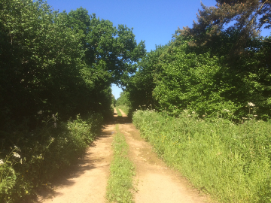
The presence of a very high water table in all seasons is confirmed by borehole measurements, as shown below in Chart 1 of HWSL’s Geotechnical Statement for planning application 14/05464.
The chart shows that deepest water table level measured in all of the 8 boreholes is 2.7m which occurred in the Summer of 2015. The proposed sand excavation of 3-4m of sand will mean that the quarry surface will be permanently below the water table under all climatic conditions, but most particularly in Winter.
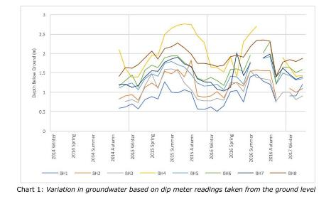
The maximum and minimum water table depths between 2014 and 2016 measured below the current surface level have been extracted from the chart above and are shown below.
Borehole | Winter  2014 | Spring  2015 | Summer  2015 | Autumn  2015 | Winter  2015 | Spring  2016 | Summer  2016 | Autumn  2016 | Winter  2016
Minimum  Depth  (m) | 0.7 | 0.8 | 1 | 1 | 0.6 | 1 | 1.4 | 1.2 | 1
Maximum  Depth  (m) | 1.6 | 2 | 2.7 | 2.7 | 1.7 | 1.9 | 2.6 | 2 | 1.8

The minimum water table depths vary between 0.7 and 1.4 metres from Winter to Summer and the maximum water table depths vary between 1.6 and 2.7 metres for all of the 8 borehole measurements.
The final excavated surface will be at a depth of 3-4 metres below the original surface so that the natural water table will always be above the final surface by a significant margin in all areas of the excavation.
There is ample evidence of water logging at current surface levels.
For example, the areas corresponding to Phase 5 and the proposed Bridleway diversion route were both flooded during the 2017/2018 winter period, and became either a lake or a boggy quagmire totally unsuitable for horses or pedestrians, as shown below. By way of contract the existing Bridleway remains usable as it is paved with hard core along its length.

Area corresponding to Phase 5
Current surface levels – Winter 2017/2018
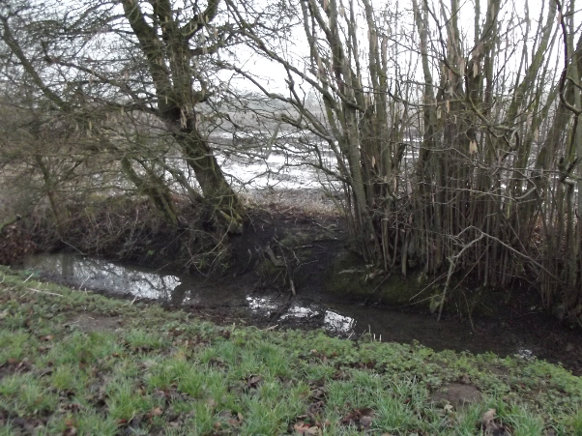
Area corresponding to the proposed bridleway diversion route
Current surface levels – Winter 2017/2018
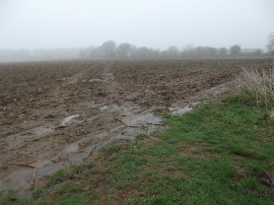
Furthermore, once the existing hard core all weather surface is removed and the sand is excavated to create a “quarry”, the future Bridleway/Brown Track will effectively be destroyed. This is because the substrate causing the high water table is Kimmeridge clay which is impervious to water.
As a consequence, a thin layer of top soil on top of clay will become a quagmire.
Further evidence for this is shown below where recent excavations at The Freeth show the thin top soil thickness (grey band), the sand layer thickness (yellow band) and the clay beneath (black band) and how such excavations rapidly fill with water following any excavation due to the high water table.
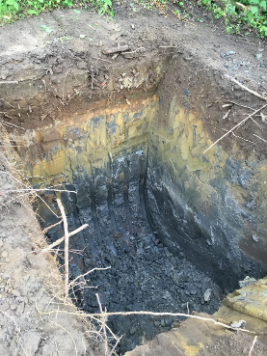 | 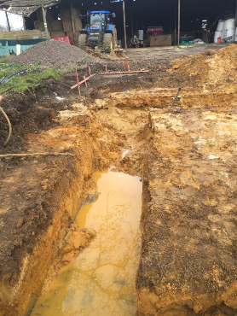
Finally, although the original route for the original Bridleway/Brown Track will be re-instated, the profile of the Bridleway/Brown Track across the excavated area will be irrevocably altered such as to make the Bridleway/Brown Track right of way unusable.
The original profile of the route taken from the contour map in HWSL’s application 14/05464 is shown below.
The final Bridleway/Brown Track profile has been constructed by “removing” the various sand thicknesses based on the nearest various borehole measurements and then adding in the topsoil thickness to represent the final surface level. The final Bridleway/Brown Track profile with the earth bunds removed shows a very steep entrance and exit due to the sand excavation as would be expected. These steep sections would be impassable in all weathers as the final levels are below the water table all the year round,

The permanent destruction of a Bridleway/Brown Track in this way is believed to be unlawful without proper authorisation.

